Ulvi Bajarani

SID 20539914

CSCI 6345 – Advanced Computer Networks

Summer II

Assignment 1

Installing Virtual Machine

**1. Some screenshots from the installation process of Virtual Box 6.1.10**

The menu with choices

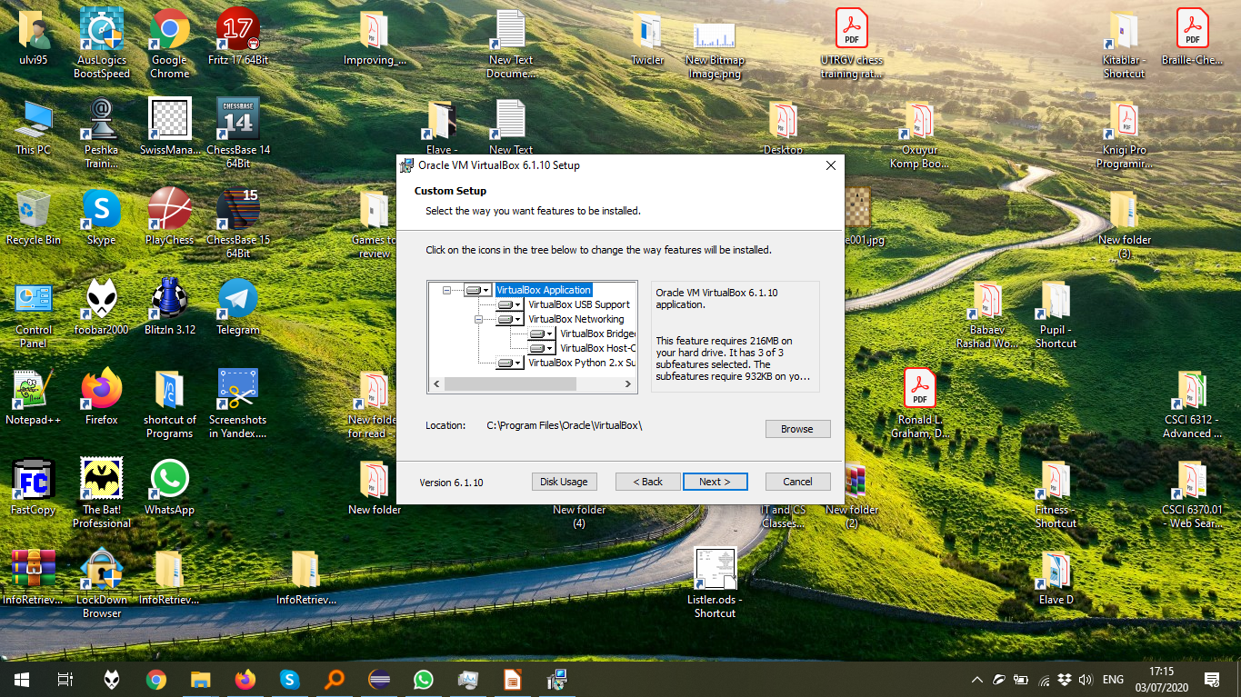The start of the VirtualBox installation process, after all confirmations.

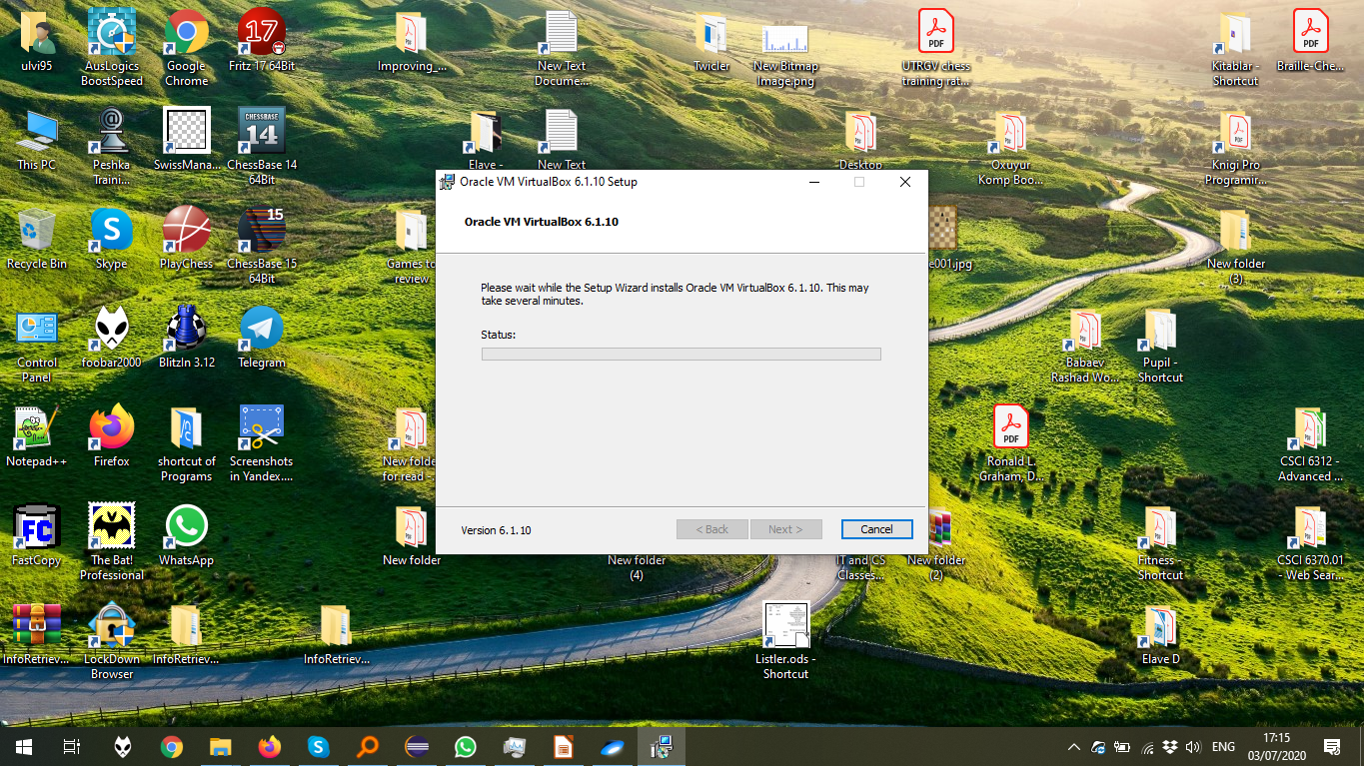

The VirtualBox window:

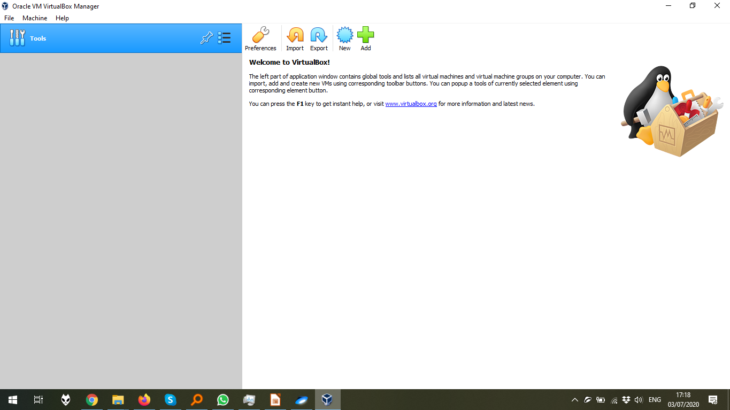

The dialog window which asks for the confirmation of VirtualBox Extension Pack

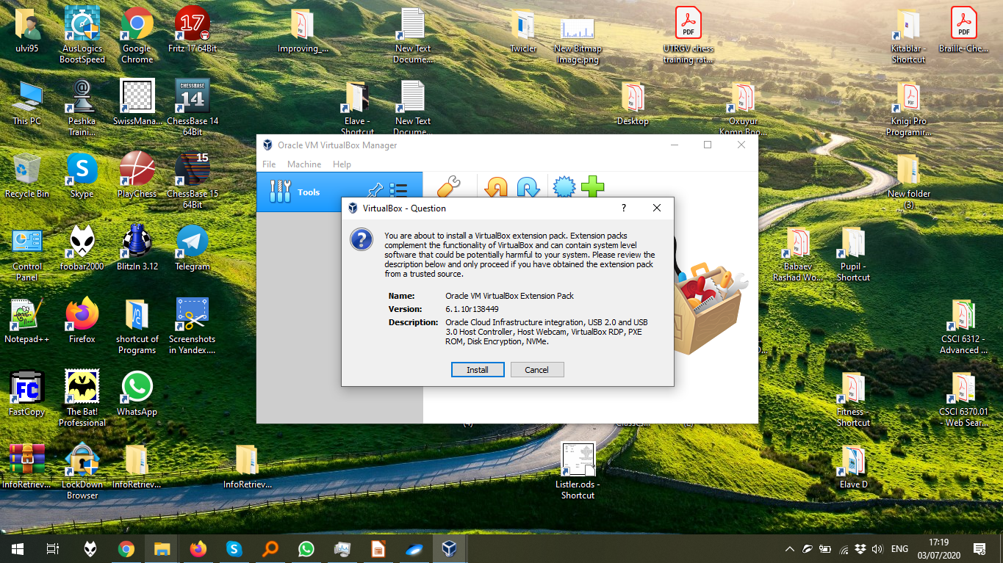

The start of the VirtualBox Extension Pack installation process, after all confirmations.

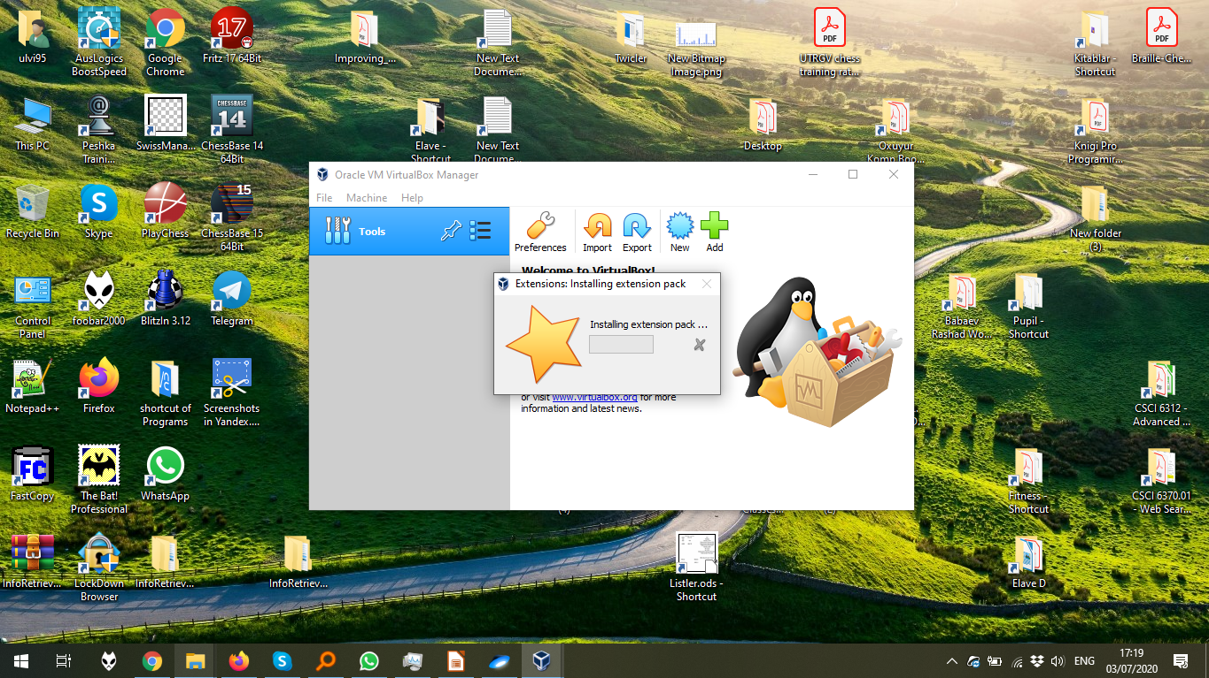

2. **The Installation of Ubuntu 20.04 in the VirtualBox**

The creation of the virtual machine by menu Machine > New Machine:

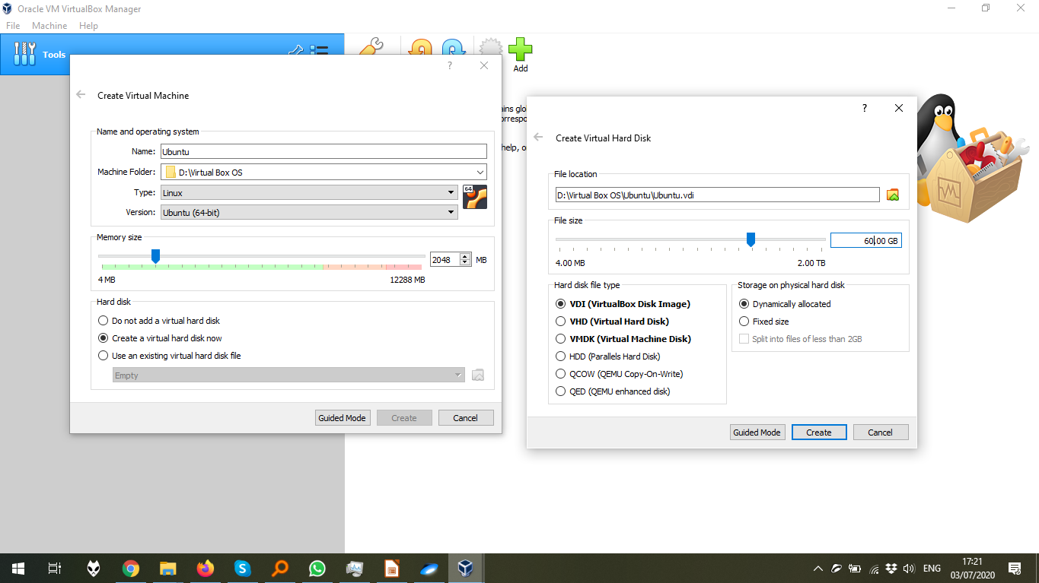

The configuration of the optical disk of the machine by Settings > Storage > the disk icon

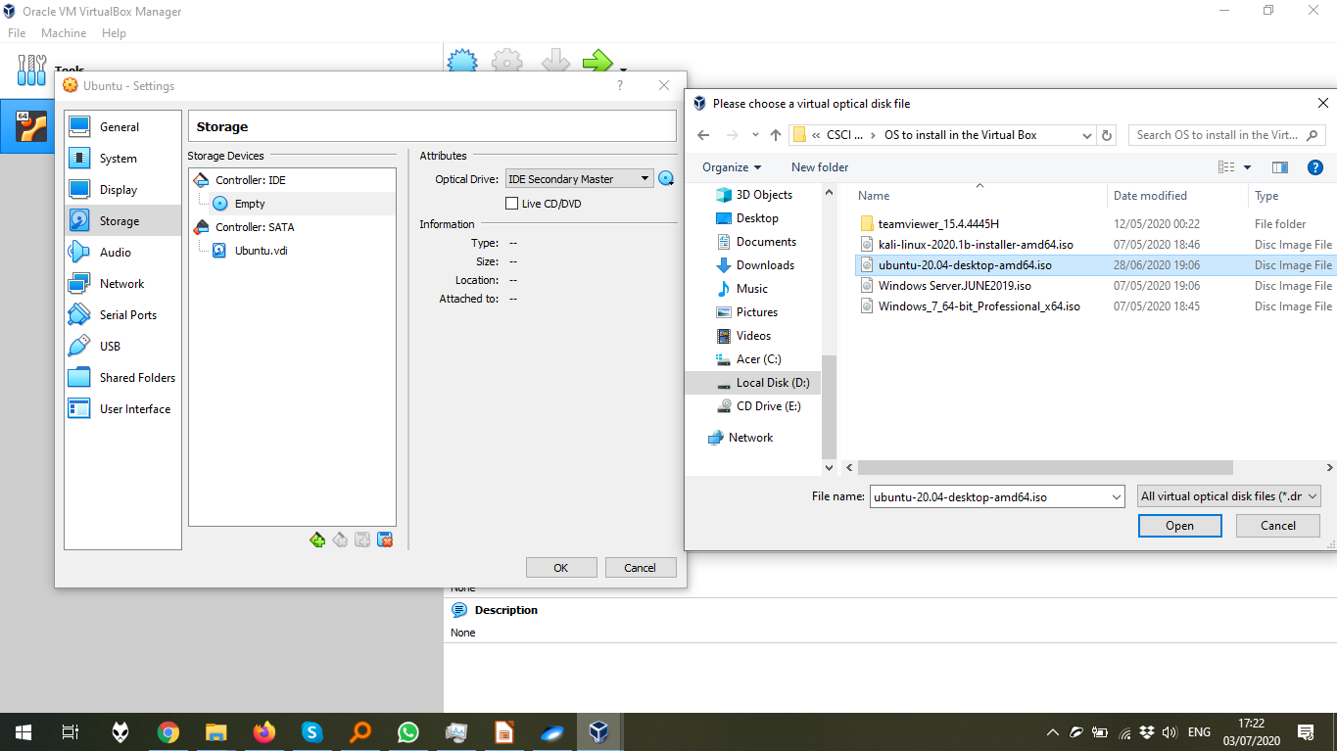

The start of the installation process after the machine starts.

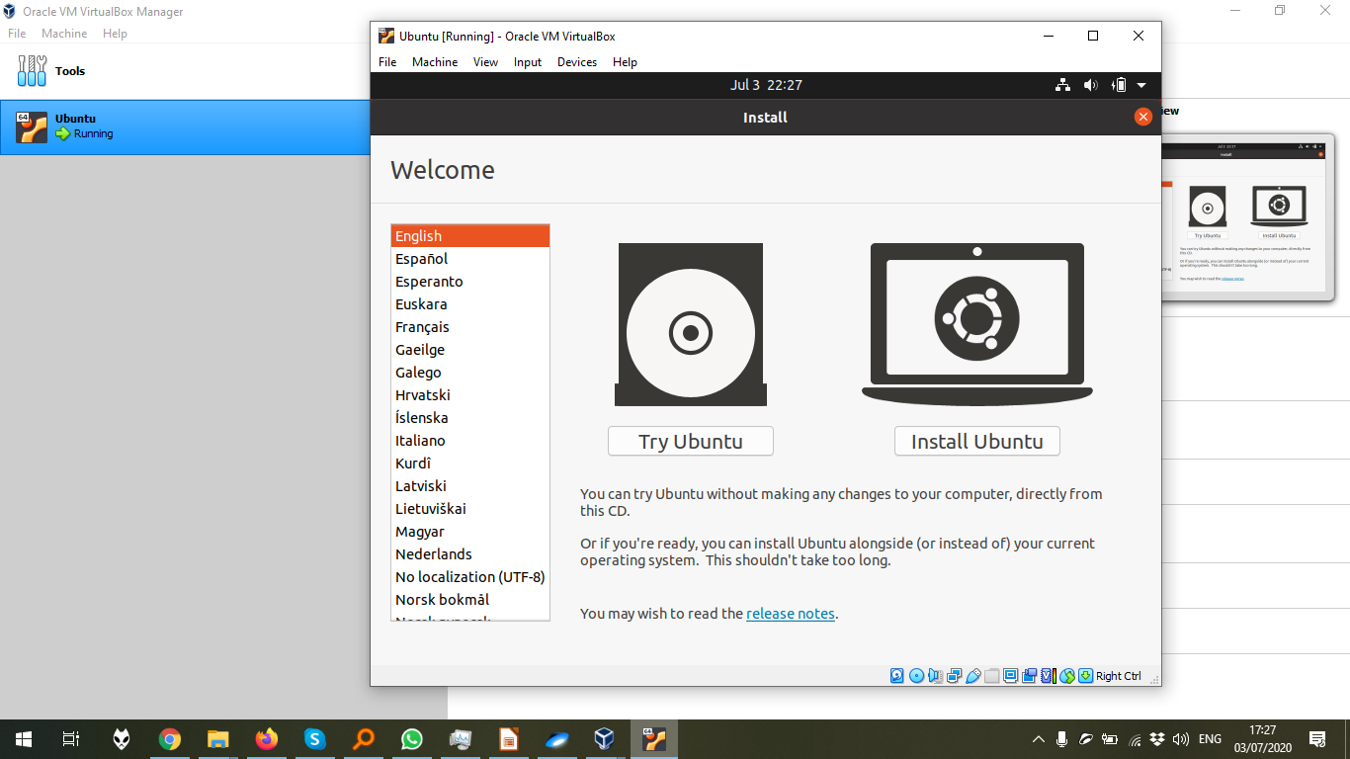

The choice menu in the installation:

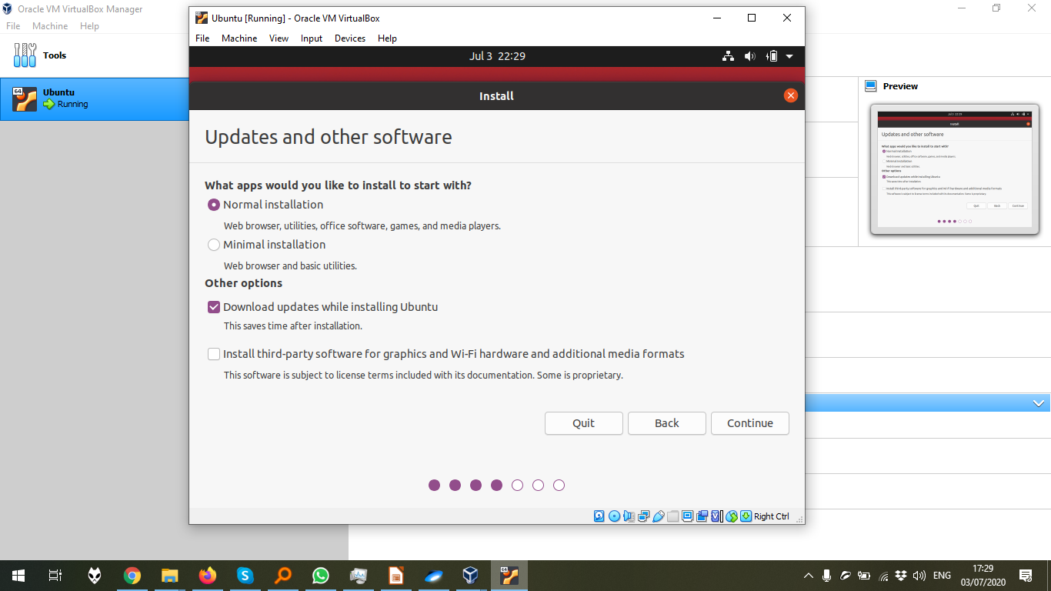

The installation process, after all confirmations.

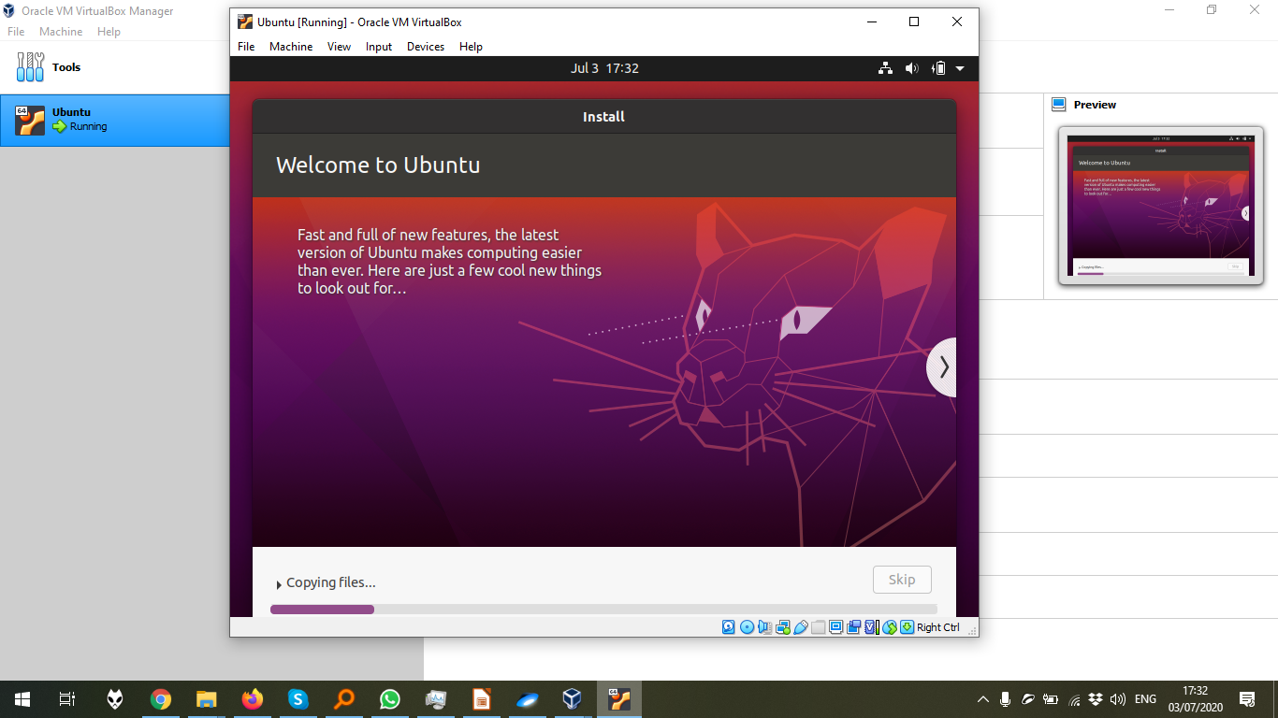

The end of the installation:

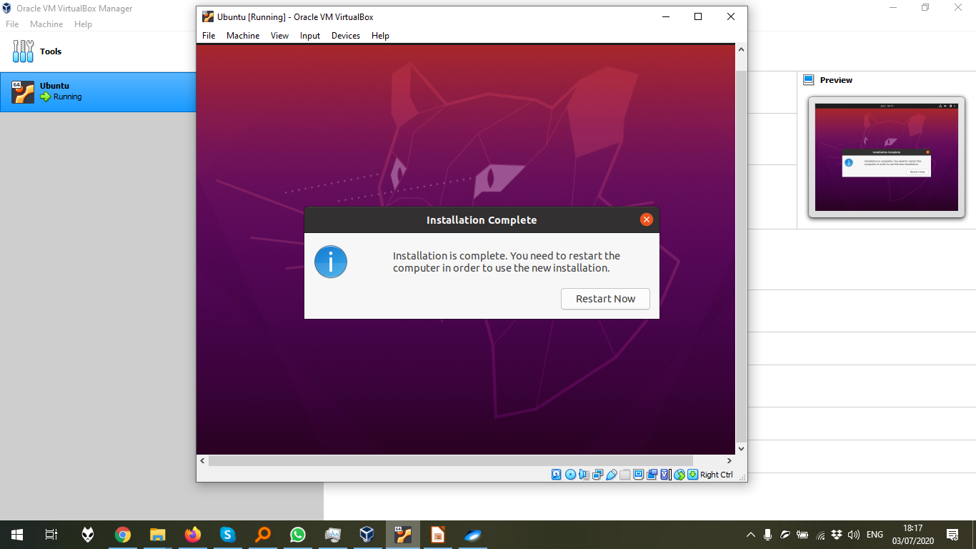

The desktop menu of Ubuntu 20.04, which was installed in the previous steps.

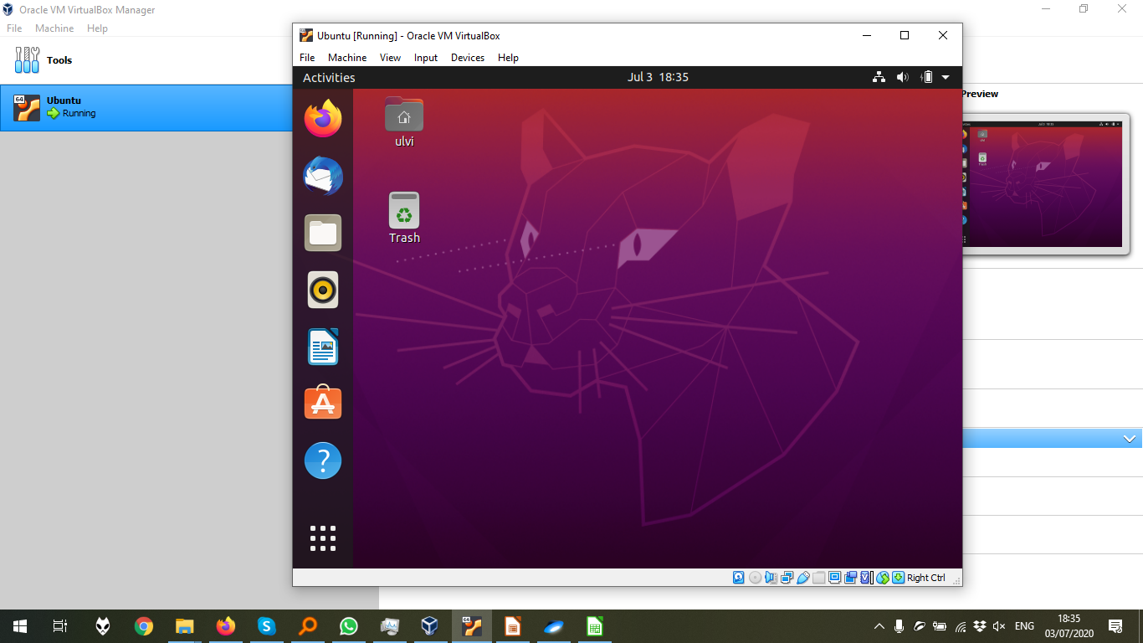

The crucial part: Adding external USB (My Wi-Fi adapter) to the list of ports. After that, the adapter should be plugged off, and after the OS loads, should be plugged on again.

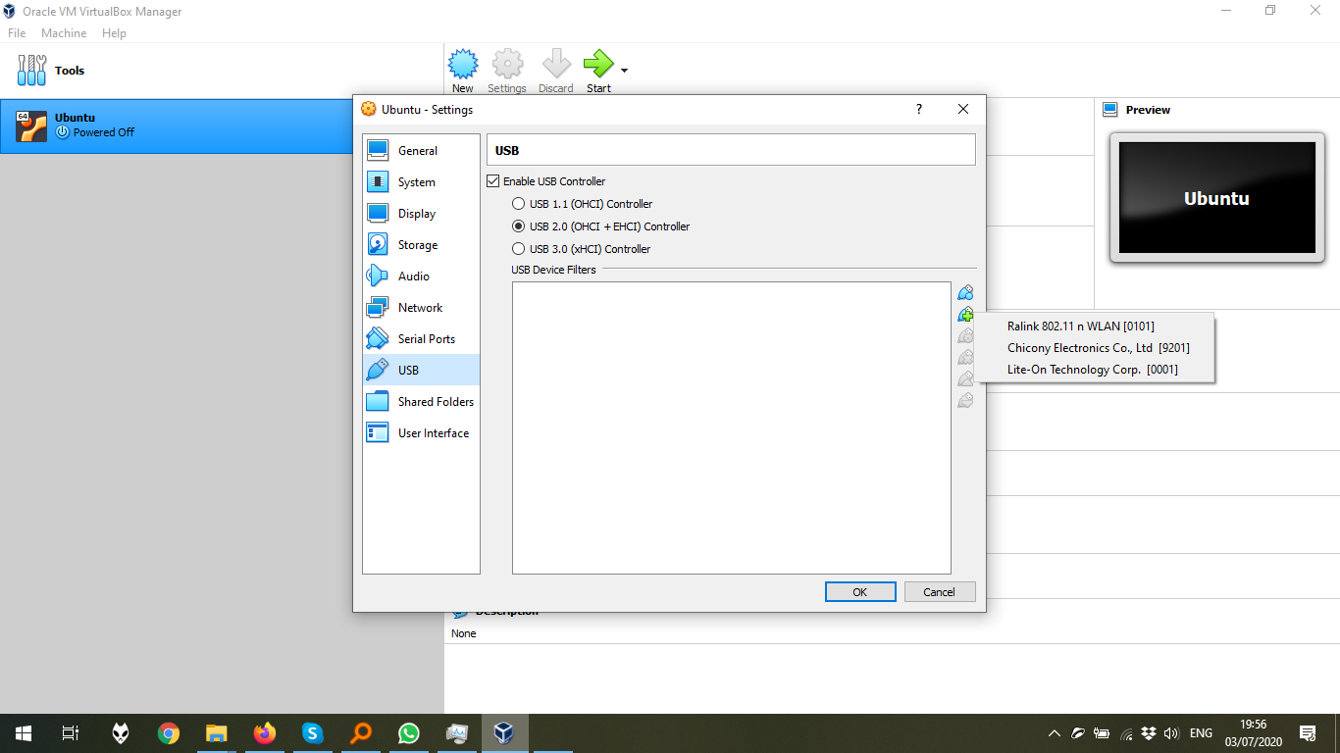The wireless connection can be seen:

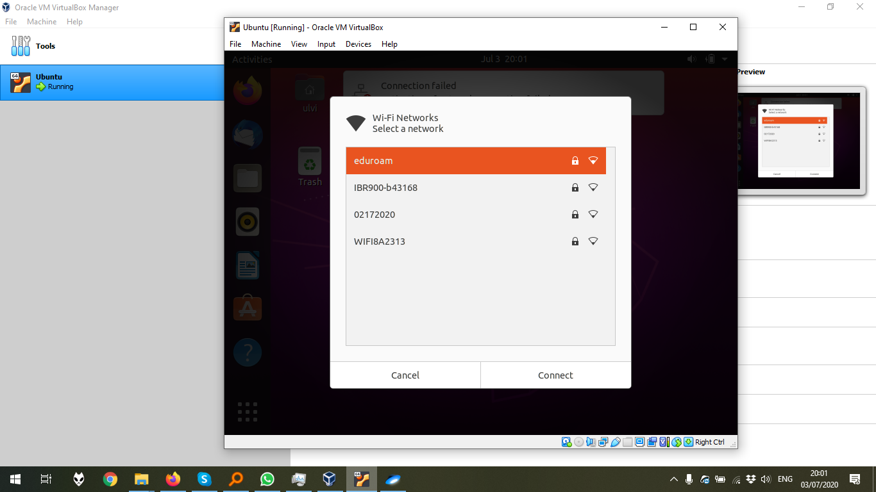

Despite that the pinging in terminal didn’t work, the internet works properly.

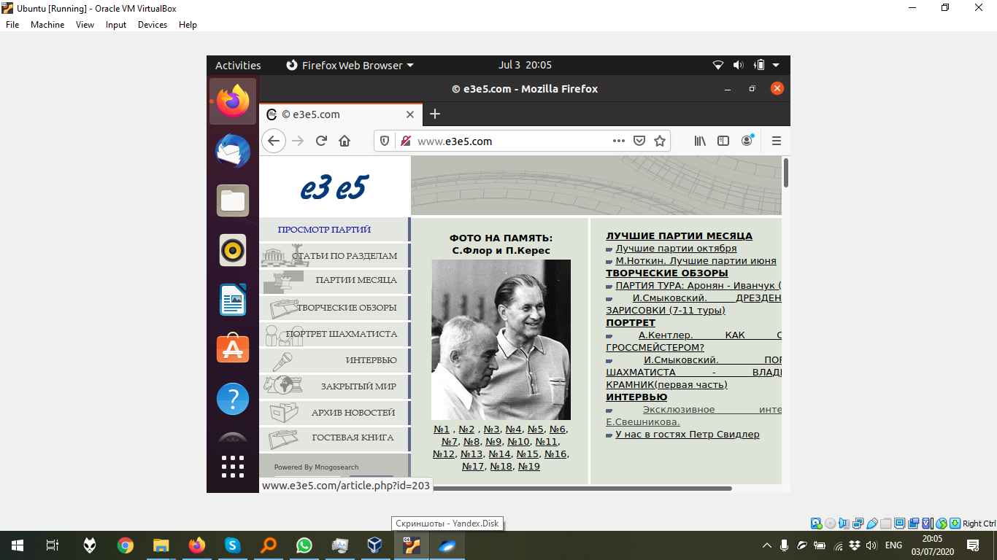

3. **The lists of printers. Since that the author doesn’t have any printers, he will not add any printers.**

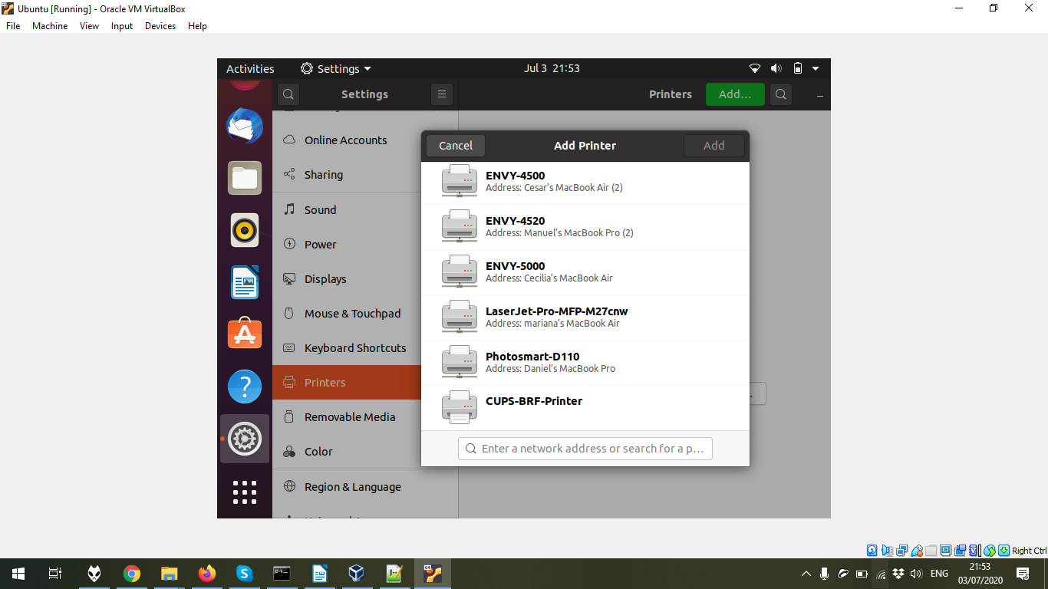

4. The execution of **ifconfig** command in the terminal. It should be noticed that at the moment, it is better to use **ip a** command, but **ifconfig** could be installed by **sudo apt-get install net-tools**, which had already been done in the tutorial before this step.

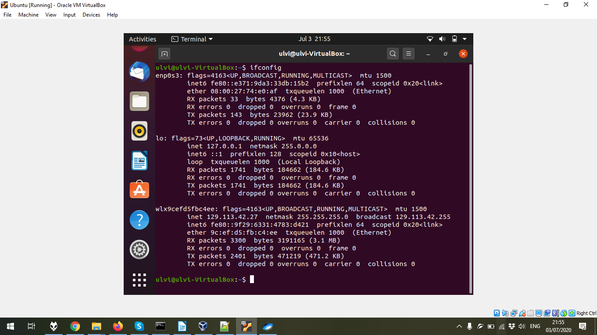

The consecutive execution of **cp , ls , mv , pwd.** Additional commands are executed to describe the result.

